**NAME: JEEVITHA.S-192324020**

**DATA BASE MANAGEMENT SYSTEM FOR DATA APPLICATIONS(CSA0555)**

**ASSIGNMENT 4: JOIN OPERATIONS**

JOINING 2 TABLES USING JOIN CLAUSE

TYPES OF JIN COMMANDS

1.outer join

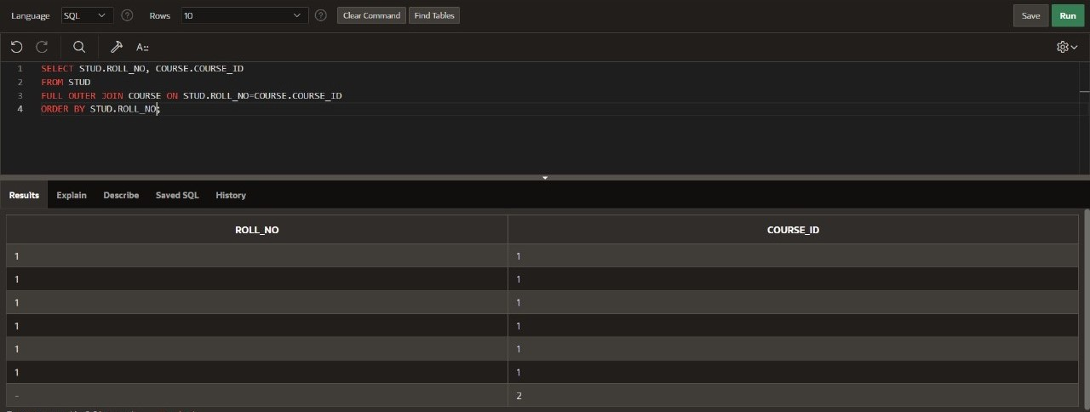

2.left join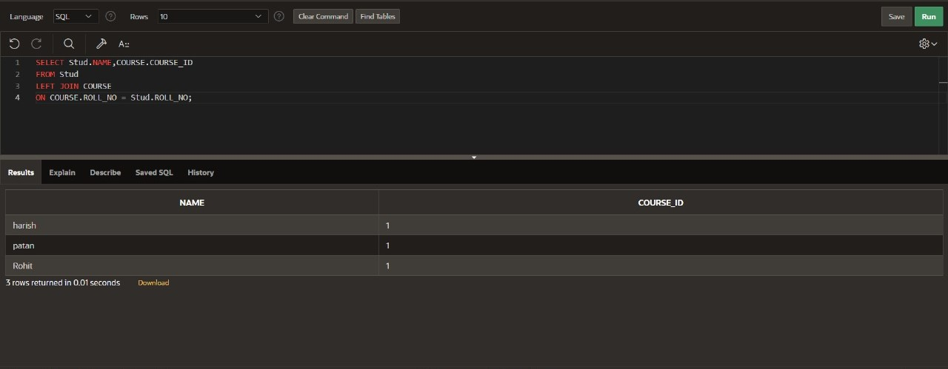

3.self join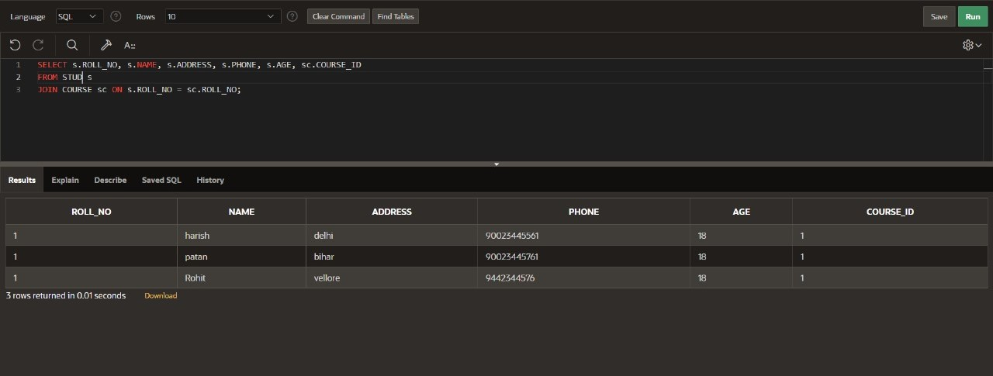

4.inner join